JQUERY:

What is jQuery

* jQuery is a small and lightweight JavaScript library.
* jQuery is cross-platform.
* jQuery means "write less do more".
* jQuery simplifies AJAX call and DOM manipulation.

jQuery is a small, light-weight and fast JavaScript library. It is cross-platform and supports different types of browsers. It is also referred as ?write less do more? because it takes a lot of common tasks that requires many lines of JavaScript code to accomplish, and binds them into methods that can be called with a single line of code whenever needed. It is also very useful to simplify a lot of the complicated things from JavaScript, like AJAX calls and DOM manipulation.

Why jQuery is required

Sometimes, a question can arise that what is the need of jQuery or what difference it makes on bringing jQuery instead of AJAX/ JavaScript? If jQuery is the replacement of AJAX and JavaScript? For all these questions, you can state the following answers.

* It is very fast and extensible.
* It facilitates the users to write UI related function codes in minimum possible lines.
* It improves the performance of an application.
* Browser's compatible web applications can be developed.
* It uses mostly new features of new browsers.

So, you can say that out of the lot of JavaScript frameworks, jQuery is the most popular and the most extendable. Many of the biggest companies on the web use jQuery.

Some of these companies are:

* Microsoft
* Google
* IBM
* Netflix

# jQuery History

jQuery was first released in January 2006 by **John Resig** at BarCamp NYC. It is currently headed by Timmy Wilson and maintained by a team of developers.

Nowadays, jQuery is widely used technology. Most of the websites are using jQuery.

### jQuery Release History

Let's see the release dates of jQuery versions.

|  |  |
| --- | --- |
| **Version No.** | **Release Date** |
| 1.0 | 26,August,2006 |
| 1.1 | 14,January,2007 |
| 1.2 | 10, September, 2007 |
| 1.3 | 14, January, 2009 |
| 1.4 | 14, January, 2010 |
| 1.5 | 31, January, 2011 |
| 1.6 | 3, May, 2011 |
| 1.7 | 3, November, 2011 |
| 1.8 | 9, August, 2012 |
| 1.9 | 15, January, 2013 |
| 1.10 | 24,May, 2013 |
| 1.11 | 24, January, 2014 |
| 2.0 | 18, April, 2013 |
| 2.1 | 24, January, 2014 |

**jQuery** is the easiest and the most popular **javascript library**. A library is just a collection of tools that allows us to implement functionality or effects without the need to write all the code that is needed to perform a certain task.

2. The purpose of jQuery is make it **easier** for you to use javascript on your website.

3. jQuery is a light-weight javascript library which means **“write less, do more”**.

4. jQuery library allows you to do following things:

* HTML/DOM(Document Object Model) Manipulation.
* CSS manipulation.
* Provides event methods to trigger and respond to a events on an html page such as mouse click, keypress etc.
* Simplifies AJAX calls.

## 2. Prerequisite

To learn jQuery faster and with less effort, you must have a basic knowledge of CSS, HTML & JavaScript.

## 3. jQuery Get Started

In this section, we will learn how to install and use jQuery in your project.

### 3.1 How to Add jQuery to your website

There are two ways you can add jQuery to your web pages.  
1. Download the jQuery library from jQuery.com -> **Not recommended method**.  
2. Include jQuery to your project using the CDN provided by Google, Microsoft etc -> **Recommended Method**.

#### 3.1.1 Download the jQuery library from jQuery.com

To download the jQuery visit this official page: [http://jquery.com/download/](https://jquery.com/download/). Here you will find two versions.

**Production version:** Download this version, if you intend to use the downloaded library for a live website.  
**Development version:** Download this version for testing and development purposes.

**After download:**  
Once you have downloaded the jQuery library. You need to **add the reference to it** from every webpage of your website, to do this add the link to the jQuery library inside <script> tag and in the <head> section of the webpage.

Place the downloaded jQuery file in the **same folder** where you have placed all of your webpages and then add the reference to the jQuery file in head section of every webpage like this:

<head>

<script src="jquery-3.4.0.min.js"></script>

</head>

#### 3.1.2 Use jQuery CDN

In this method, **you do not have to download and host the jQuery file**, you can use the jQuery file provided by Google and Microsoft CDN (Content Delivery Network). These **CDNs are fast** as they deliver the file from your **nearest hosting server** which is why I have recommended this method. All the tutorials that I have written on jQuery, I have used the CDN provided by Google.

**jQuery file provided by Google CDN:**  
You refer the file like this in the head section of your webpage:

<head>

<script src="https://ajax.googleapis.com/ajax/libs/jquery/3.4.0/jquery.min.js"></script>

</head>

## 4. First jQuery Example

In the following example we are using the jQuery to hide all the paragraphs when the button is clicked. We have added to the reference to jQuery CDN file in the <script> tag inside <head>.

<!DOCTYPE html>

<html>

<head>

<script src="https://ajax.googleapis.com/ajax/libs/jquery/3.4.0/jquery.min.js">

</script>

<script>

$(document).ready(function(){

$("button").click(function(){

$("p").hide();

});

});

</script>

</head>

<body>

<h2>jQuery tutorial on Beginnersbook.com</h2>

<p>This is my first paragraph</p>

<p>This is my second paragraph</p>

<button>hide</button>

</body>

</html>

**Output:**  
**Before the button is clicked:**  
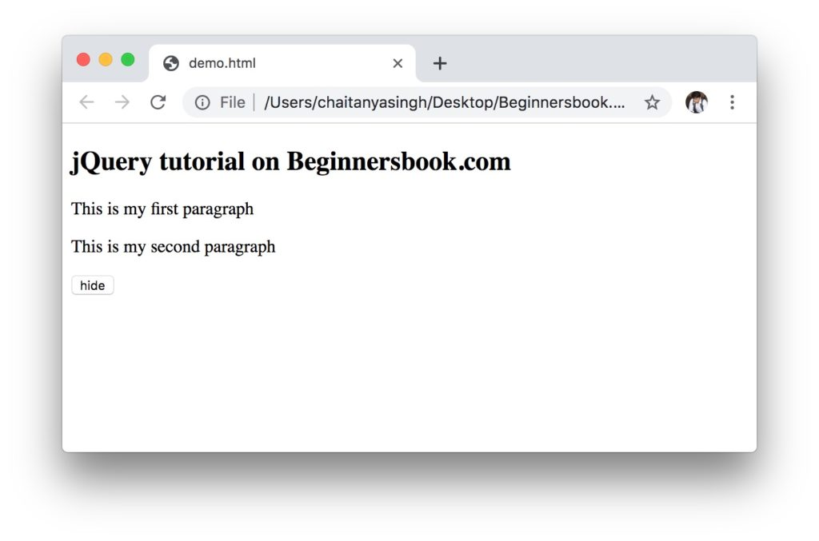  
**After the button is clicked:**  
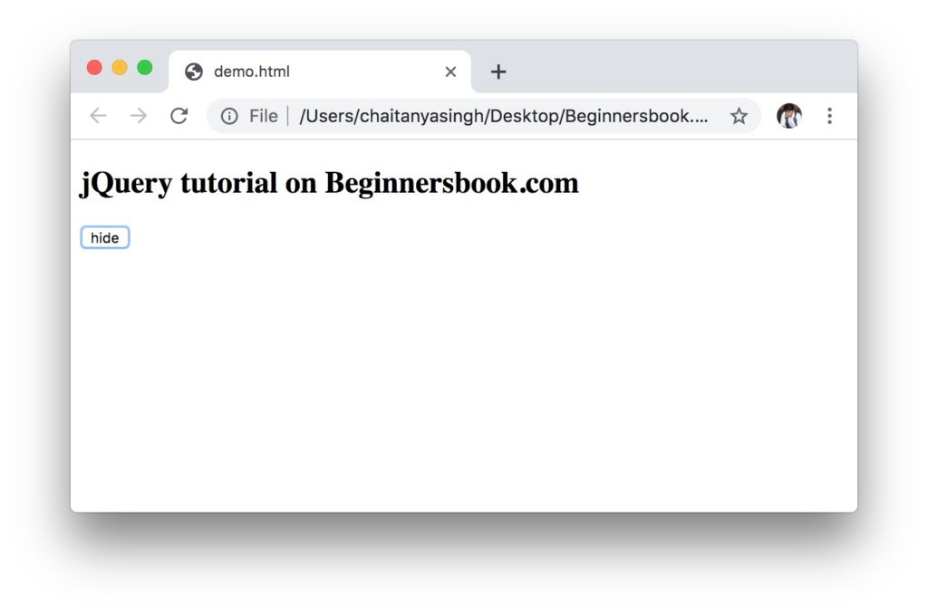

There are couple of things you may be wondering about in the above example. Don’t worry, we will discuss everything in detail in the separate tutorials. I have added the links to those tutorials at the end of this article. For now, just discuss little bit about everything so we get to know what is happening here.

The following is the jQuery part in the above example:

<script src="https://ajax.googleapis.com/ajax/libs/jquery/3.4.0/jquery.min.js">

</script>

<script>

$(document).ready(function(){

$("button").click(function(){

$("p").hide();

});

});

</script>

Here the first line is the reference to the jQuery CDN, this gives us access to the **jQuery library** which is full of tools that we can use to implement functionality or effect in our webpage without writing code. For example, here we use the jQuery method hide() to hide all the paragraphs, the actual implementation of hide() method is available in the file which you are **referring using the CDN**.

### 4.1 The Document Ready function

We always write the jQuery code inside document ready function like this:

$(document).ready(function(){

// jQuery code

});

We do this to prevent any jQuery code from running before the document is finished loading. It is always best to wait for the document to be fully loaded before any of the jQuery code runs, this prevents the unexpected behaviour that may arise if write the jQuery code outside document ready function.

|  |  |  |
| --- | --- | --- |
| LINK | EXAMPLE | DESCRIPTION |
| [* Selector](https://beginnersbook.com/2019/04/jquery-selector-select-all/) | $(“*”) | Selects all the elements of an html page. |
| [#id Selector](https://beginnersbook.com/2019/04/jquery-id-selector/) | $(“#myid”) | Selects the element with id value equals to  “myid”. |
| [.class Selector](https://beginnersbook.com/2019/04/jquery-class-selector/) | $(“.myclass”) | Selects all the elements with class “myclass”. |
| [Multiple class Selector](https://beginnersbook.com/2019/04/jquery-multiple-classes-selector/) | $(“.myclass1,.myclass2”) | Selects all the elements with class “myclass1”  or “myclass2”. |
| [Element Selector](https://beginnersbook.com/2019/04/jquery-element-selector/) | $(“p”) | Selects all the paragraphs |
| [Multiple elements Selector](https://beginnersbook.com/2019/04/jquery-multiple-elements-selector/) | $(“h2,p,a”) | Selects all the h2, p and a elements of an  html page |

## What can we do using jQuery Selectors

You can select html elements based on their name, class, id, attribute, value etc. and then you can apply behaviour to them.

**For example** lets say you have an html page with a paragraph and a button, you can apply behaviour to the button using jQuery selector to hide the paragraph when the button is clicked, or you can change the background colour of the paragraph when the button is clicked, you can do whatever you want, basically jQuery selectors give you full control over the html elements.

## Types of jQuery Selectors

There are number of jQuery Selectors which you can use to manipulate the html elements. Lets take few examples to understand the various types of selectors.

jQuery selector starts with $ sign followed by parenthesis. For example $(p) selects all the paragraphs of the html page.

### jQuery Element Name Selector

jQuery element name selector syntax is $(element_name). It selects the html element based on the element name. We provide the element name inside parenthesis to select it.

In the following example we have an html page that contains few elements such as head, body, h2, p, button etc. In the script section of the web page we have added the jQuery function that selects the h2 element and hide it when the button is clicked.

We have used the selector on h2 element and we are calling hide function like this: $(“h2”).hide(); this will select all the h2 element of the html page and hide them when the button is clicked.

<!DOCTYPE html>

<html>

<head>

<script src="https://ajax.googleapis.com/ajax/libs/jquery/3.4.0/jquery.min.js">

</script>

<script>

$(document).ready(function(){

$("button").click(function(){

$("h2").hide();

});

});

</script>

</head>

<body>

<h2>jQuery Selectors Example on BeginnersBook.com</h2>

<p>This is a paragraph. It contains some text.</p>

<button>Click Me!</button>

</body>

</html>

**Output:**  
**Before button is clicked:**  
This is when the above html page is loaded in the browser, we have not yet clicked the button.  
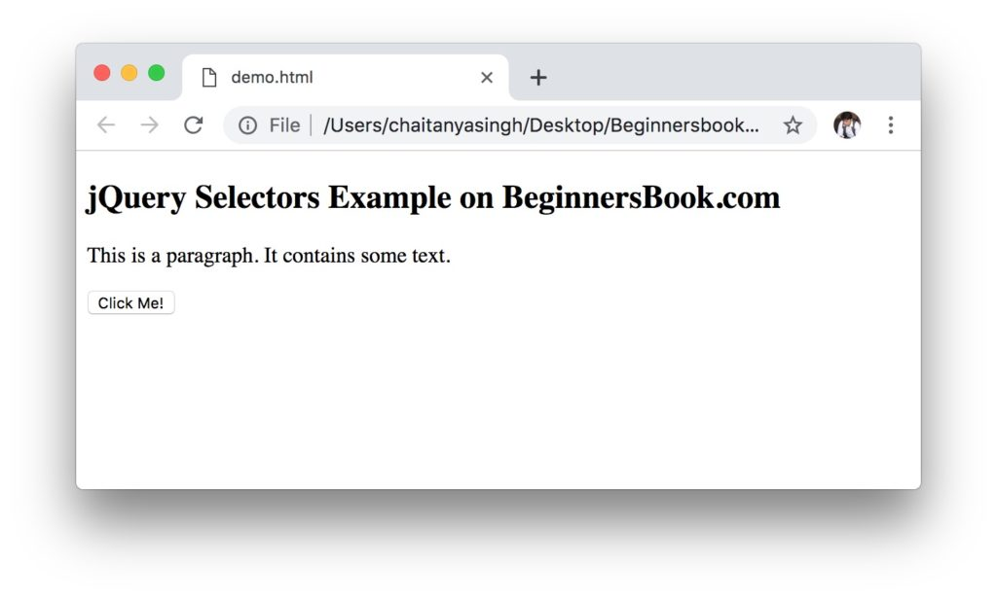  
**After button is clicked:**  
Once the button is clicked it selected all the h2 element of the html page and hidden them.  
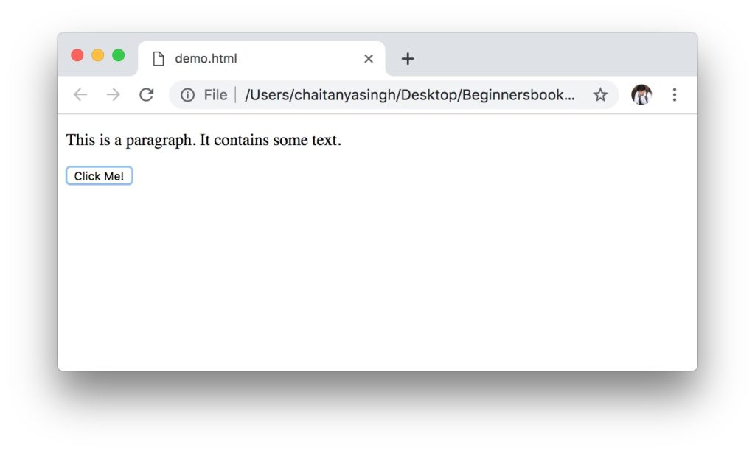

### jQuery Element #id Selector

In the above example we have seen how to select an html element based on the name, however the downside of using name selector is that it selects all the elements of the html page, for example $(p) selects all the paragraphs of the html page.

What if we want to select only a particular paragraph and not all the paragraphs of an html page, we can do this by assigning an id to that particular paragraph and then select the para based on the id.

The syntax of element #id selector is:

$("#my_id")

This will select the element that has the id my_id.

Lets take an example.

<!DOCTYPE html>

<html>

<head>

<script src="https://ajax.googleapis.com/ajax/libs/jquery/3.4.0/jquery.min.js">

</script>

<script>

$(document).ready(function(){

$("button").click(function(){

$("#myid").hide();

});

});

</script>

</head>

<body>

<h2 id="myid">jQuery element id selector example</h2>

<p>This example is published on beginnersbook.com</p>

<p>This is another paragraph.</p>

<button>Click Me!</button>

</body>

</html>

**Output:**  
**Before button is clicked:**  
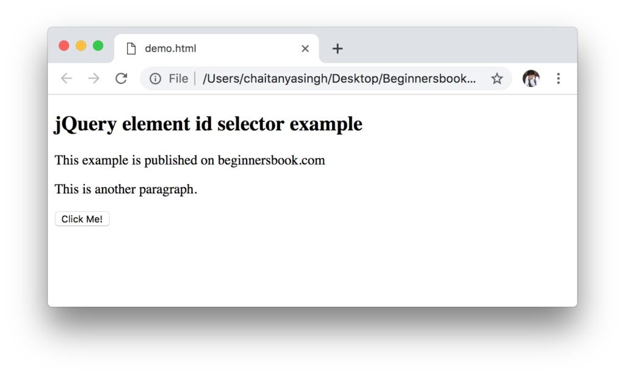  
**After button is clicked:**  
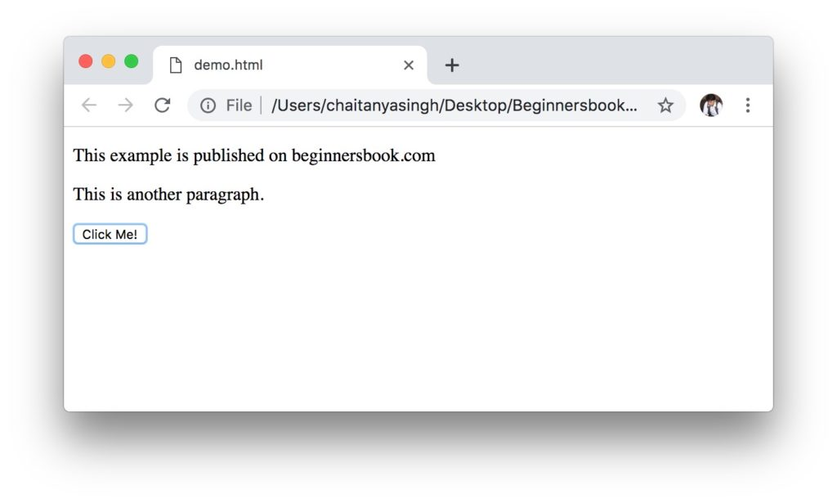

### jQuery Element .class Selector

In the above example, we have seen the element id selector. The limitation of id selector is that an id is unique and two html elements cannot have the same id.

What if we want to hide a particular h2 element and a particular para element on a button click event. We can achieve this with the help of **element class selectors**, we can assign the same class to that h2 element and p element and call the hide function on the element class selector. The syntax of element class selector is:

$(".myclass")

This will select all html elements that has the class myclass.

Lets take an example:  
In the following example we have assigned a class myclass to three html elements, h2, p and button element. We have called the hide function on the element class selector where we passed the class name as myclass. This should hide all these three elements on the button click event.

<!DOCTYPE html>

<html>

<head>

<script src="https://ajax.googleapis.com/ajax/libs/jquery/3.4.0/jquery.min.js">

</script>

<script>

$(document).ready(function(){

$("button").click(function(){

$(".myclass").hide();

});

});

</script>

</head>

<body>

<h2 class="myclass">jQuery element class selector example</h2>

<p>This example is published on beginnersbook.com</p>

<p class="myclass">This is another paragraph.</p>

<button class="myclass">Click Me!</button>

</body>

</html>

**Output:**  
**Before button is clicked:**  
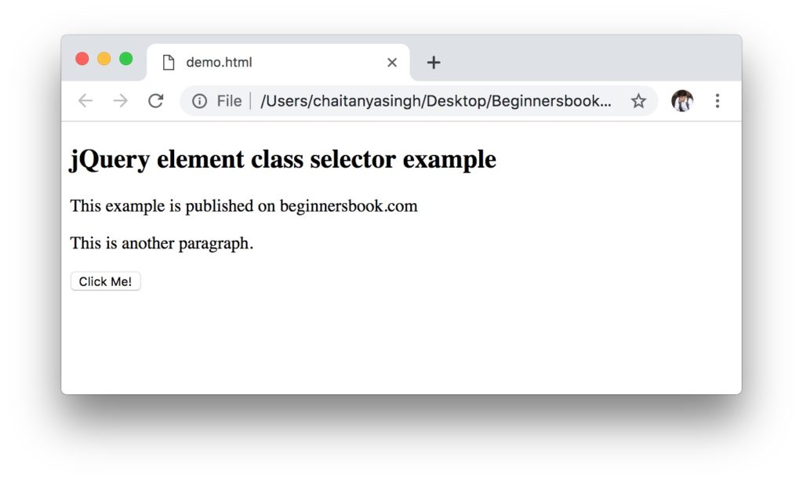  
**After button is clicked:**  
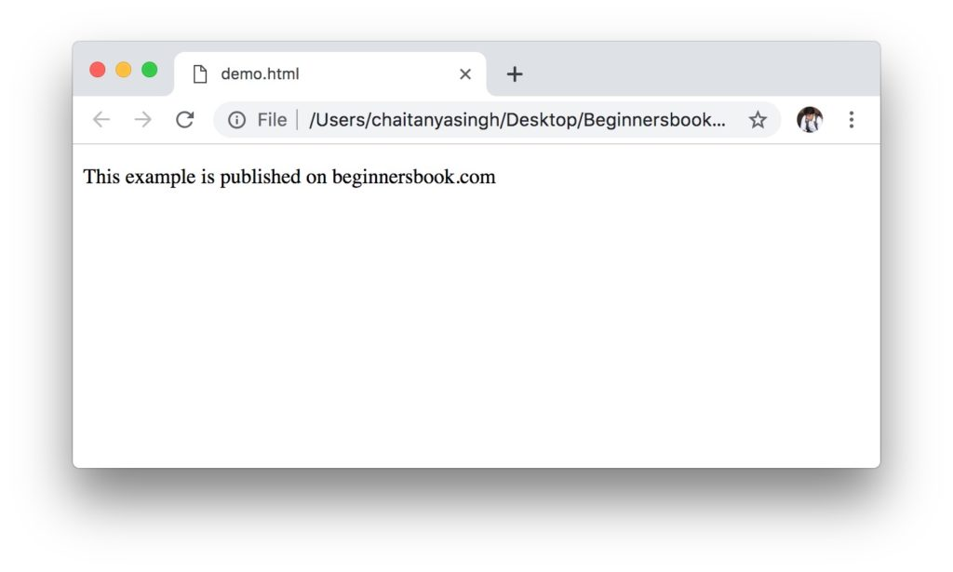

**jQuery’s event API** provides several useful methods that can be used to create dynamic web pages. Events are nothing but actions that you can perform on a web page such as mouse click, mouse hover, double click etc. **In jQuery we can detect such events** and can write a custom code (function) for each of these events. This gives us freedom to do whatever we want to do on an occurrence of an event, such custom functions are called **event handlers**. In this guide, we will discuss various events provided by jQuery event API.

## jQuery Event Method Syntax

This is a button click event, it will trigger when we click on a button on a webpage.

$("button").click();

Now that we have detected a particular event using above code, our next step to write a custom code that executes when a button click event occurs. For this we have to write a custom function called event handler as shown below:

$("button").click(function(){

// custom code for event handler

});

## $(document).ready() method

Before we start learning various events, lets first understand the use of **most commonly used method** in jQuery. $(document).ready() method executes when a document (a web page) is **fully loaded in the browser**. We almost always write event handlers inside this method because we do not want to trigger an event when our page is not fully loaded.

We write a **event handler inside $(document).ready() method** like this: In the following example we are hiding all the paragraphs on a button click event. We have written the button click event handler inside $(document).ready() method so that the event only triggers when the page is fully loaded.

$(document).ready(function(){

$("button").click(function(){

$("p").hide();

});

});

## jQuery Events

### jQuery Mouse Events

|  |  |
| --- | --- |
| TUTORIAL LINK | DESCRIPTION |
| [click](https://beginnersbook.com/2019/04/jquery-click-event/) | jQuery click event occurs when a user clicks on an html element. |
| [dblclick](https://beginnersbook.com/2019/04/jquery-dblclick-event/) | jQuery dblclick event occurs when a user double clicks on an html element. |
| [mouseenter](https://beginnersbook.com/2019/04/jquery-mouseenter-event/) | jQuery mouseenter event occurs when the mouse pointer enters the html element. |
| [mouseleave](https://beginnersbook.com/2019/04/jquery-mouseleave-event/) | jQuery mouseleave event occurs when the mouse pointer leaves the html element. |
| [mousedown](https://beginnersbook.com/2019/04/jquery-mousedown-event/) | jQuery mousedown event occurs when any of the mouse button is pressed down while the mouse pointer is over an html element. |
| [mouseup](https://beginnersbook.com/2019/04/jquery-mouseup-event/) | jQuery mouseup event occurs when any of the mouse button is released while the mouse pointer is over an html element. |
| [hover](https://beginnersbook.com/2019/04/jquery-hover-event/) | jQuery hover event is a combination of mouseenter() and mouseleave() methods. First event handler function executes when mouse pointer enters the html element and the second event handler function executes when the mouse pointer leaves the html element. |

### jQuery Form Events

|  |  |
| --- | --- |
| TUTORIAL LINK | DESCRIPTION |
| [focus](https://beginnersbook.com/2019/05/jquery-focus-event/) | jQuery focus event occurs when a form field gets focus. |
| [blur](https://beginnersbook.com/2019/05/jquery-blur-event/) | jQuery blur event occurs when a form field loses focus. |
| [submit](https://beginnersbook.com/2019/05/jquery-submit-event/) | jQuery submit event occurs when a form is submitted. |
| [change](https://beginnersbook.com/2019/05/jquery-change-method/) | jQuery change event occurs when the value of an element has been changed. The applicable elements for this event are: <input>, <textarea> and <select> |

### jQuery Keyboard Events

|  |  |
| --- | --- |
| TUTORIAL LINK | DESCRIPTION |
| [keypress](https://beginnersbook.com/2019/05/jquery-keypress-event/) | jQuery keypress event occurs when a button is pressed down. The keypress event is not triggered for special keys such as ALT, CTRL, SHIFT, ESC. |
| [keydown](https://beginnersbook.com/2019/05/jquery-keydown-event/) | jQuery keydown event occurs when a keyboard key is pressed down. Unlike keypress event, this event is triggered for ALT, CTRL, SHIFT, ESC keys. |
| [keyup](https://beginnersbook.com/2019/05/jquery-keyup-event/) | jQuery keyup event occurs when a keyboard key is released |

### jQuery Window Events

|  |  |
| --- | --- |
| TUTORIAL LINK | DESCRIPTION |
| [resize](https://beginnersbook.com/2019/05/jquery-resize-event/) | jQuery resize event occurs when the browser window is resized. |
| [scroll](https://beginnersbook.com/2019/05/jquery-scroll-event/) | jQuery scroll event occurs when user scrolls in the specified html element. |

In the following example, we have associated the click method to the [**id selector**](https://beginnersbook.com/2019/04/jquery-id-selector/), we have provided the button id, so when we click on the button, the click event is triggered. In the click event function we are hiding the h2 elements using hide() method.

You can see in the output screenshots that when you click on the “Hide Heading” button, the heading of the document gets hidden.

<!DOCTYPE html>

<html>

<head>

<script src="https://ajax.googleapis.com/ajax/libs/jquery/3.4.0/jquery.min.js">

</script>

<script>

$(document).ready(function(){

$("#myid").click(function(){

$("h2").hide();

});

});

</script>

</head>

<body>

<h2>jQuery click event example</h2>

<p>This example is published on beginnersbook.com. The main heading

will be hidden when you click on the "Hide Heading" button</p>

<button id="myid">Hide Heading</button>

</body>

</html>

# jQuery dblclick() Method

BY CHAITANYA SINGH | FILED UNDER: [**JQUERY**](https://beginnersbook.com/category/jquery/)

**jQuery dblclick() Method** attaches a double click event handler function to an html element. This event handler function executes when a user double clicks on the attached html element.

## jQuery dblclick() Method Syntax

$(selector).dblclick(function(){

//event handler code. This code will execute

// when a user double clicks on the selected html element.

});

Here $(selector) is a [**jQuery selector**](https://beginnersbook.com/2019/04/jquery-selectors/) that selects an html element and the **dbclick() method** attaches that selected element to the event handler function.

## jQuery dblclick() Example

In the following example we have attached the double click event handler function to the jQuery selector that selects h2, p and button elements, which means whenever a user double clicks on any of these elements, they will be hidden because in event handler function we are calling [**hide() method**](https://beginnersbook.com/2019/04/jquery-effects-show-and-hide/) like this: $(this).hide(); that hides the current element.

<!DOCTYPE html>

<html>

<head>

<script src="https://ajax.googleapis.com/ajax/libs/jquery/3.4.0/jquery.min.js">

</script>

<script>

$(document).ready(function(){

$("h2, p, button").dblclick(function(){

$(this).hide();

});

});

</script>

</head>

<body>

<h2>jQuery double click event example</h2>

<p>This example is published on beginnersbook.com. When you double

click on the heading, paragraph or button, they will be hidden</p>

<button>Button</button>

</body>

</html>

**Output:**  
**Before a user double clicks on any html element:**  
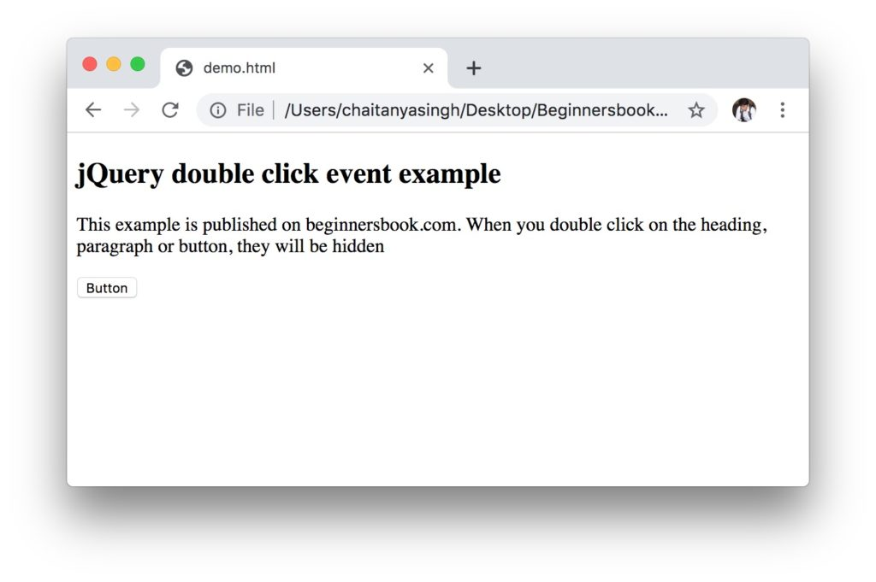  
**After a user double clicks on the h2 heading:**  
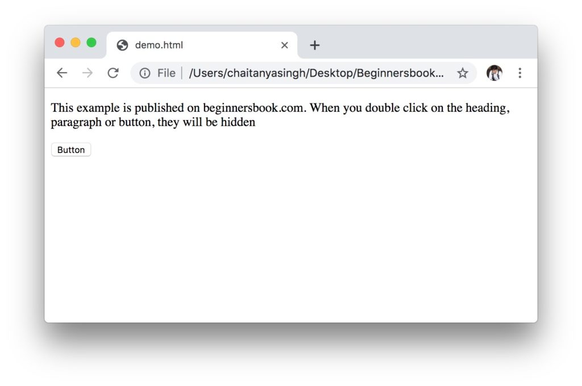  
**After a user double clicks on the paragraph:**  
